ASTRO SAGE DATA ANALYSIS PROJECT.

SUBMITTED BY:

TARUN KUMAR ANAND

OCT,24 BATCH

# The AstroSage Dataset include(Schemas) –

* **_id:** Unique identifier for each record.
* **user:** User ID associated with the record.
* **chatStatus:** Status of the chat (e.g., incomplete, failed, completed).
* **guru:** Unique identifier for the guru.
* **guruName:** Name of the guru.
* **gid:** Guru ID.
* **uid:** User ID.
* **consultation Type:** Type of consultation (e.g., Chat, Call).
* **website:** Source of the consultation (e.g., gurucool).
* **Refund Status:** Indicates if the session is refundable or not (e.g., no-refund).
* **is WhiteList User:** Boolean indicating if the user is whitelisted.
* **chat Seconds:** Duration of the chat in seconds.
* **queue:** Boolean indicating if the session was queued.
* **FreeCall:** Boolean indicating if the call was free.
* **Free Chat:** Boolean indicating if the chat was free.
* **CreatedAT:** Original creation date and time.
* **updatedAt:** Original update date and time.
* **__v:** Version key.
* **statementEntryId:** Identifier for the statement entry.
* **chatStartTime:** Start time of the chat.
* **chatEndTime:** End time of the chat.
* **timeDuration:** Duration of the session.
* **callChannel:** Channel used for the call.
* **callIvrType:** IVR type used during the call.
* **callStatus:** Status of the call.
* **CallSid:** Unique identifier for the call session.
* **amount:** Amount charged for the session.
* **astrologerCallStatus:** Status of the astrologer during the call.
* **astrologerOnCallDuration:** Duration of the astrologer's call.
* **astrologersEarnings:** Earnings of the astrologer from the session.
* **netAmount:** Net amount after deductions.
* **region:** Region of the user.
* **userCallStatus:** Status of the user's call.
* **userOnCallDuration:** Duration of the user's call.
* **rating:** Rating assigned based on the session's status

# Objective Questions

# 1) What is the total no. of tables present in the data?

**Ans**- Only one table is present in the dataset for analysis.

**2)** **What is the total no. of attributes present in the data?**

**Ans-** There are total 35 attributes present in the raw datasheet for analysis. And in cleaned datasheet there are 30 attributes are present.

**Function used –** =CountA()

**3) The data consists of some inconsistent and missing values so ensure that the**

**data used for further analysis is cleaned.**

**Ans-** Data has been cleaned with the help of different excel functions Aggregate functions, Logical functions, Condition aggregation, Text functions, Date functions, Lookup functions and Formating functions.

## 1) CHANGE OF NAMES OF COLUMNS.

1)_id – Unique ID

2) uid – User ID

3)guruName – Guru Names

4) gid – Guru Unique ID

5) consulation Type – Consultation Type

6) website – Source of Consultation

7)CreatedAT – Creation Date

8) chatStatus – Chat Status

9) timeDuration – Chat Duration (seconds)

10) __v – Version Key

11) userCallStatus – User Call Status

12) astrologerCallStatus – Astrologer Call Status

13) userOnCallDuration – User Call Duration

14) astrologerOnCallDuration- Astrologer Call Duration

**Excluded Columns –** is WhiteList User ,queue, guru, updatedAt, statementEntryId, chatStartTime, chatEndTime , CallSid.

**Included Columns –** Creation Date Imputed, Creation Month , Creation Time, Hour of Creation.

## 2) REPLACING.

1)Replaced Dr Balkrisna, Dr. Balkrisna and Astro Dr Balkrisna with Astro Dr Balkrisna. As gid and guru were same for all three, as gid = 19.

2) Replaced Tarot Chanchal singh, Tarot Chanchal with Tarot Chanchal singh as gid = 101.

3) Replaced Astro Jha Guruji, Astro Jha with Astro Jha Guruji as gid = 174.

4) Replaced Astro Dr Shreyi, Dr. Shrey with Astro Dr Shreyi as gid = 195.

5) Replaced Astro Aacharya Dev, Acharya Dev with Astro Aacharya Dev as gid = 196.

# 3) MISSING VALUES.

1)There was blank spaces in the column Chat Status , Chat Time , Chat date. As the blank spaces shows the call service taken, so the missing values in this columns are filled with “Call option used.”

2)There was blank spaces in the column Call Status , Call channel, Call IVR type, User call status, Astrologer call status , User call duration, Astrologer call duration. As the blank spaces shows the chat service taken, so the missing values in this columns are filled with “Chat option used.”

3) In the astrologer earning column there was missing values so it is replaced with “Nothing earned.”

## 4) COLOUR FORMATTING.

**Home tab -> Styles -> Conditional Formatting -> Highlight cells rule -> Test that contain -> Write text and choose colour. (This will help to highlight the texts)**

1)In the Consultation Type column the “Chat” text is formatted in yellow colour while “Call” text in green colour.

2)In the columns Chat Status , Chat Time , Chat date the “Call option used” text is highlighted in green colour.

3) In the columns Call Status , Call channel, Call IVR type, User call status, Astrologer call status , User call duration, Astrologer call duration the “Chat option used” text is highlighted in yellow colour.

4) In the astrologer earning column the text “Nothing earned” is highlighted in red colour.

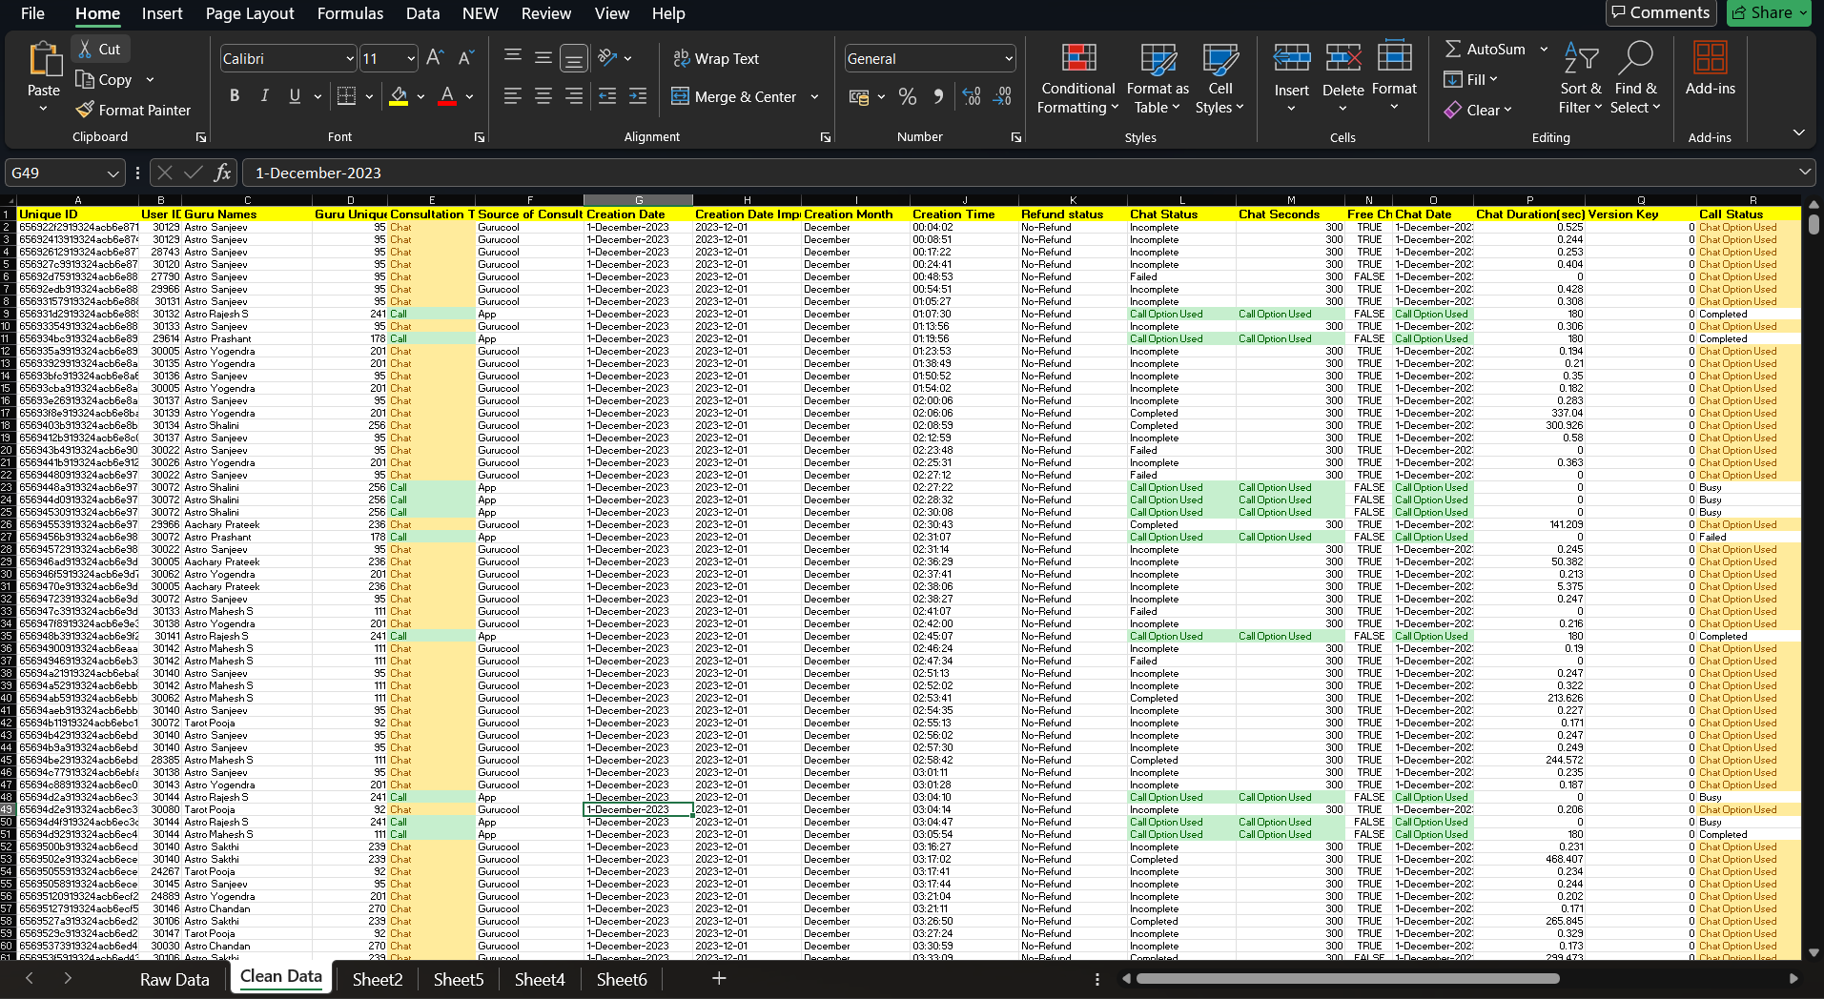

**4) What is the average daily call volume over the day by day and what’s the change on it?**

**Ans-**  The average daily call volume is **250.**

**Formula used-** =average(call volume column)

**The day by day change in the call volume can be seen in the column “Change in call volume” and can also be seen in the chart which shows call volume over the day by day basis.**

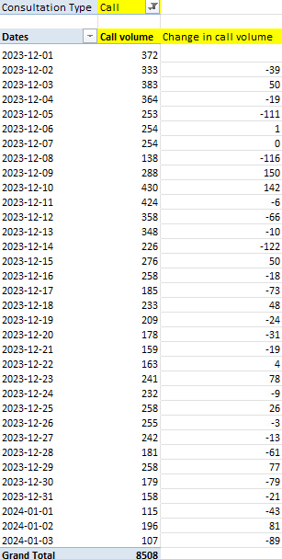 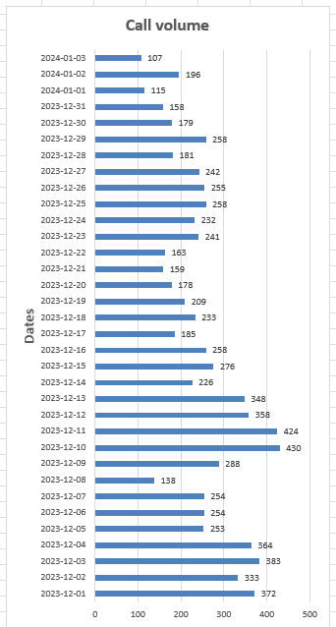

**5) Which months experienced the highest and lowest call volumes?**

**Ans-** The given period spans a total of 34 days, covering the final 31 days of December and the first 3 days of January

On 10/12/23 there was highest call volume i.e **430**.

**Formula used-** =Max(call volume column)

On 03/01/2024 there was lowest call volume i.e. **107.**

**Formula used -** =Min(call volume column)

**December –** Highest call volume i.e 26488.

**January –** Lowest call volume i.e 1539.

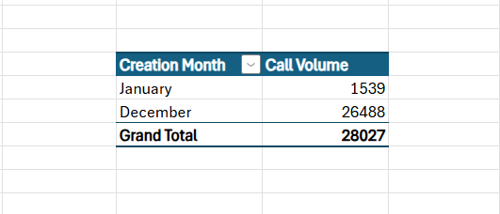

**6) What is the total operational cost for that month?**

**Ans –**The operational cost for that month= Total net income of month – Astrologer income of month

**1) December –**

Astrologer earning = 93786.16

Function used - =SUMIF('Clean Data'!J:J,"December",'Clean'!AB:AB)

Net Earning = 202214.6

Function used- =SUMIF('Clean Data'!J:J,"December",'Clean'!AC:AC)

Operation cost =202214.6 - 93786.16

**December Operation cost = 108428.44**

**2) January –**

Astrologer earning = 5360.41

Function used - =SUMIF('Clean Data'!J:J,"January",'Clean'!AB:AB)

Net Earning = 11772.69

Function used- =SUMIF('Clean Data'!J:J,"January ",'Clean'!AC:AC)

Operation cost = 11772.69 – 5360.41

**January Operation cost = 6412.28**

**7) What is the average number of calls handled per agent per day?**

**Ans –**

**Total Calls – 8508**

Function Used- =COUNTIF('Clean Data'!F:F,'Clean '!$F$9)

**Number of days – 34**

Function Used - =COUNT(UNIQUE('Clean'!H:H))

**Number of agents(Guru)- 131**

Function used - =COUNT(UNIQUE('Clean'!E:E))

**First we have to find average number of calls per day.**

**Average number of calls per day**= Total calls / Number of days

= 5808 / 34

= 250.23

**Now we have to find average number of calls handled by per agent per day.**

**Average number of calls handled by per agent per day** = Average number of calls per day / Number of Agent

= 250.23 / 131

= 1.91

**So we can say that approx. 2 calls are handled by per person per day.**

**8) How many repeat callers are there, and what percentage of total calls do they represent?**

**Ans –**

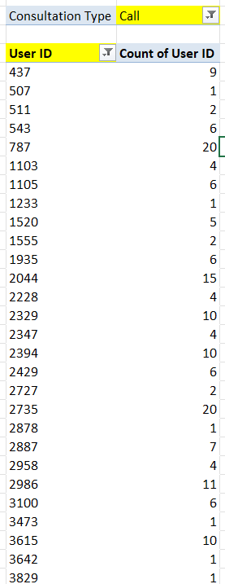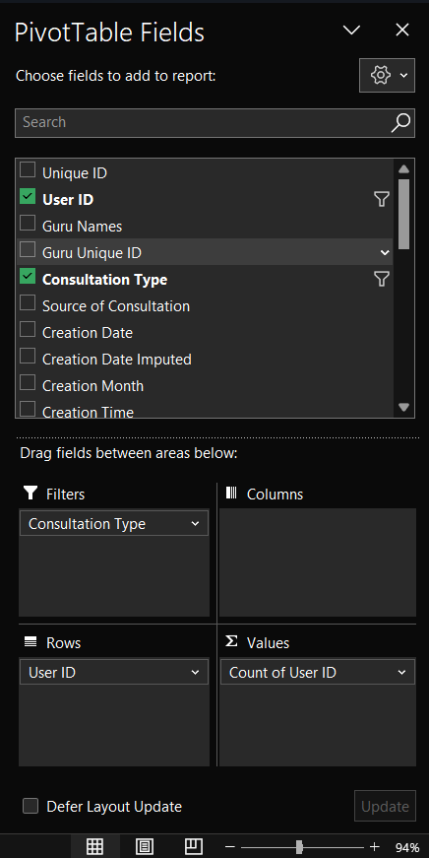

With the help of this pivot table we can find the total number of callers.

**Total number of callers=3629**

Formula used- =COUNT()

Now we have to find the repeater callers. The callers who use the call service more than one time,

For that we can apply the filter on the pivot table in the user id section, which will show the callers who called more then one time.

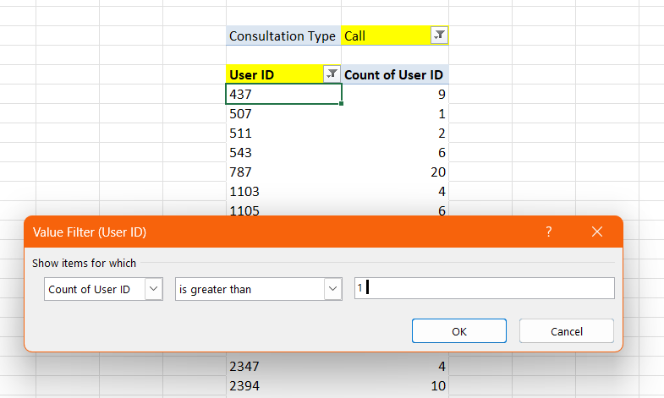

## Repeater callers = 1277

Formula used- =COUNT()

Single time callers (Non repeaters) = Total callers – Repeater callers

Non Repeater callers = 2352

**PERCENTAGE OF TOTAL CALLS –**

Total number of calls = 8508 ( count of calls )

Caller placed 6156 repeated calls.

**Repeated calls = 6156 – 1st call placed by callers**

= 6156 – 1277 (count of repeated callers )

**Repeated calls = 4879**

**Percentage of repeated calls** = (Repeated calls *100)/Total calls

= (4879*100/8508)

**Percentage of repeated calls = 57.34 %**

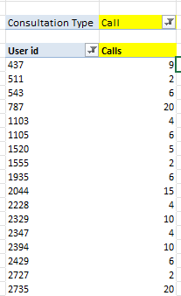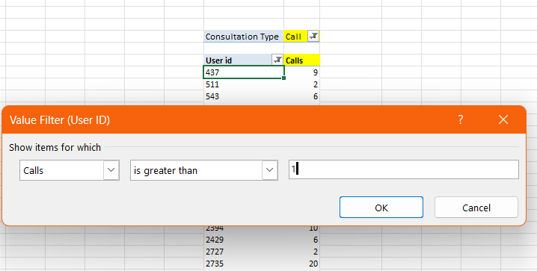

**9) What is the total sales generated by the call centre for each product category?**

**Ans-** Website (Source of consultation ) taken as the product categories.

Highest sales generated by App. And lowest by Dashboard.

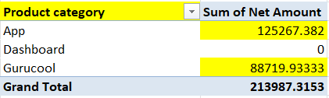

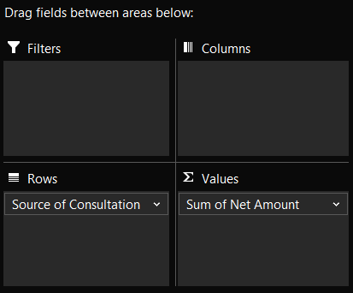

**10) How many calls were made for each user ID and guru ID?**

**Ans- The list is very long as there 3629 users who used call service and they made 8508 calls in total.**

Formula used- =COUNTIF('Clean'!F:F,"Call") (To measure total calls )

=COUNT() (To measure users)

With the help help of pivot table we can see the calls made for each User ID and Guru ID.

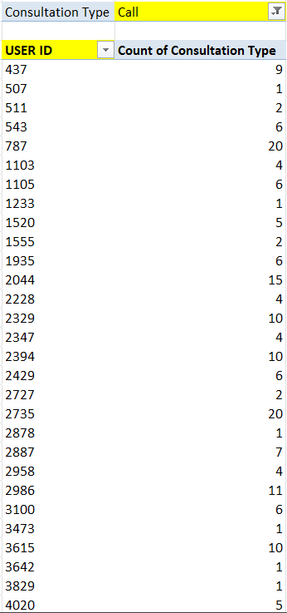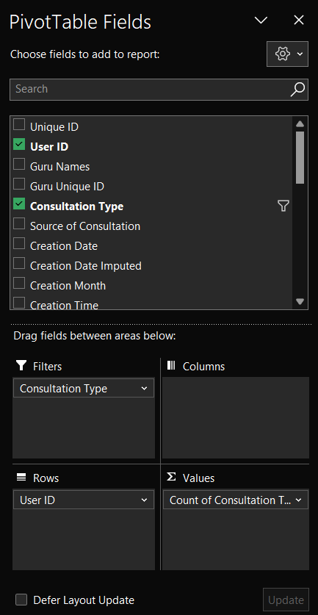

**There are 131 Gurus who received calls from users.**

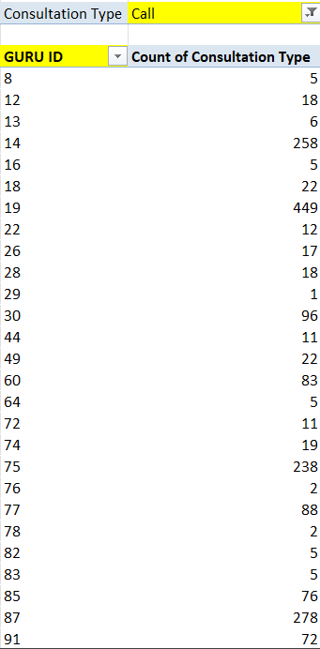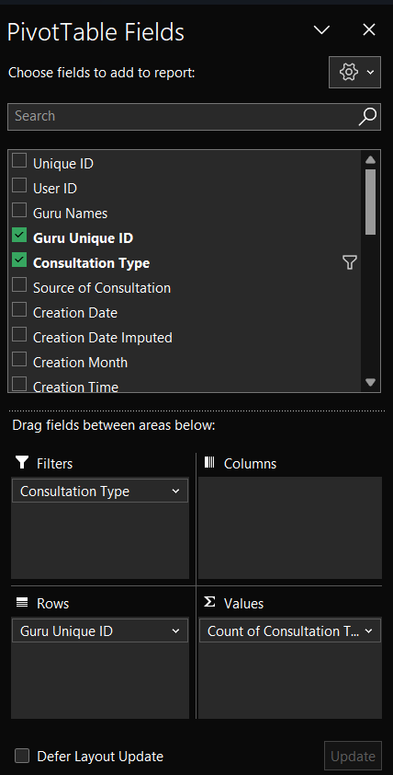

**11) What is the correlation between call duration and customer satisfaction?**

**Ans- The correlation between call duration and customer satisfaction is 0.000202451**

Formula used – =CORREL('Clean'!Z2:Z28028,'Clean '!AE2:AE28028)

A correlation of (-0.00025) indicates an extremely weak negative relationship between call duration and rating. However, the value is so close to 0 that it essentially suggests no meaningful linear relationship between the two variables.

## 12) Which guru have the highest and lowest customer satisfaction scores?

**Ans-** If we take the average of all gurus rating then Tarot Rittika(Guru id – 80) got the lowest satisfaction score but she only consulted once and only one user rated her. While Tarot Mystical(Guru id – 305) got the highest average rating but she consulted only two users with chat service.

**So I think its not fare to decide lowest and highest satisfaction scores with only two or one user review.**

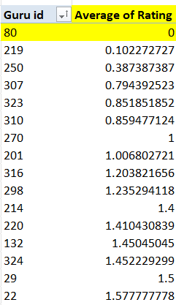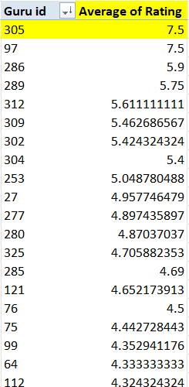

**Another approach is to find out which Guru receive high number of lowest satisfaction score i.e. 0,and same for highest satisfaction score i.e. 8**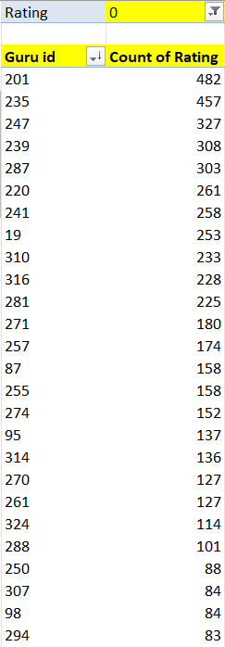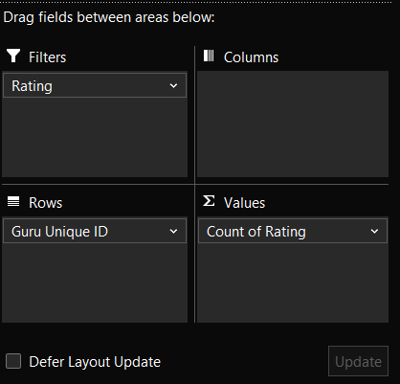

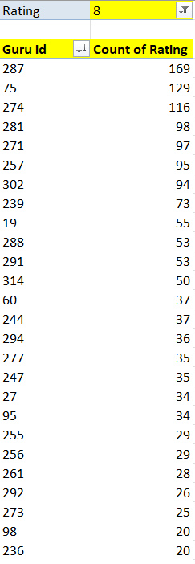

**For the pivot table we can see that Astro Yogendra (Guru id- 201 ) got the highest number of 0 i.e. 482 times , so we can consider him as lowest satisfaction score earned guru.**

**While Astro Krishaa ( Guru id -287 ) got the highest number of 8 which is 169 times , so we can considered her as highest satisfaction score earned guru.**

(Here sorting is use to see the highest count.)

**13) What is the average customer satisfaction score by month?**

**Ans –** There are only two months are given in data i.e. December 2023 and January 2024.

**December – 2.95 January – 2.68**

Formula used –

=AVERAGEIF(Sheet1!J:J,"December",Sheet1!AE:AE)

=AVERAGEIF(Sheet1!J:J,"January ",Sheet1!AE:AE)

Sheet1 later renamed as RAW DATA.

**14) How many categorical columns are there in the data? [Search about**

**categorical and continuous data, and try to answer this question]**

**Ans -**   
**1) Categorical Columns:**

**Definition:** These are variables that represent distinct categories or groups. The values are typically qualitative and can be divided into discrete, non-numeric groups or labels.

## Categorical columns are:(From raw dataset)

_id CallSid

user, astrologerCallStatus

chatStatus region

guru userCallStatus

guruName gid

uid callStatus

consultationType callIvrType

website FreeChat

RefundStatus callChannel

isWhiteListUser FreeCall

queue

**They are categorical columns because the show characteristics like –**

**Qualitative:** They represent descriptive characteristics or labels.

**Discrete:** There is a limited or fixed number of values.

**Non-numeric:** Though some categorical variables can be numeric (like ID numbers), the numbers don't have mathematical meaning.

## 2) Continuous Columns:

**Definition:** These are variables that can take on any value within a certain range and are typically numeric. They represent measurable quantities.

## Continuous Columns are : (From raw data)

chatSeconds timeDuration

amount astrologerOnCallDuration

astrologersEarnings netAmoun

userOnCallDuration rating

**They are Continuous columns because the show characteristics like –**

**Quantitative:** The data can be measured and expressed numerically.

**Continuous:** They can take any value within a range, including decimals.

**Mathematically meaningful:** You can apply arithmetic operations like addition and subtraction to continuous data.

# Subjective Question

**1) Should the investment be used to hire more agents, improve training**

**programs, or upgrade call center technology?**

**Ans- 1) Hiring more agents**

**There are 131 Gurus, who provide service to the users.**

Total call receive = 8508

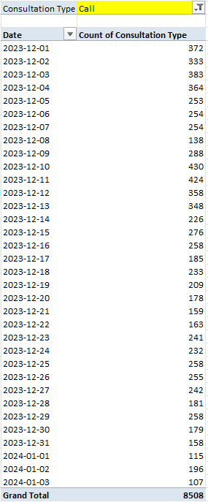

**Average number of calls per day = 250** (Formula - =AVERAGE())

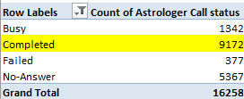

**% of calls gets complete = 56.41 %** {Formula= (Completed calls * 100)/ total calls}

Call centre receive approx. 250 calls per day but only 56.41% of calls gets complete in total. There is a need of investment in the hiring of agents to manage the workload.

## 2) Upgrade Call centre technology.

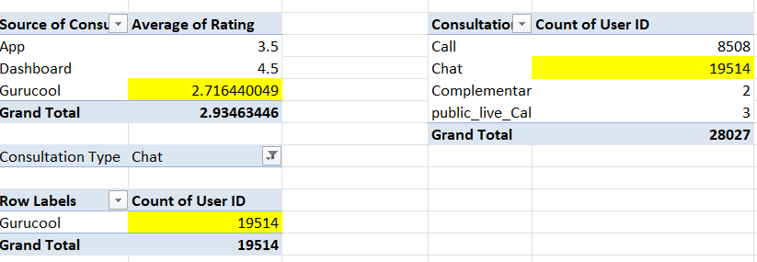

There is need for technology upgrades because 69.62% of total users use chat service. And Gurucool is only one platform which provide the service of the Chat to the users. But the average rating of the Gurucool is 2.71, which is the clear indicator of unsatisfied users. So it is very necessary to improve technology and provide satisfaction to the users . Investing in technology upgrades will help to improve the overall experience and will help to increase the retention rate of the users. But there are some risks in upgrading technology.

## 3) Training .

Only 27.49% of users are satisfied with the service.

**Total users = 28027**

**Satisfied user (Rating-5,6,7,8) = 27.49 %**

(formula- =(SUM(satisfied users)*100/total users))

**Unsatisfied user (Rating-0,1,2,3,4) = 72.51 %**

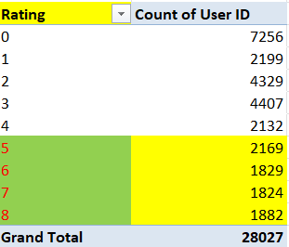

**I think the investment should be used to improve training program. There are three reasons.**

# REASON 1 -

The total call duration of Astrologer is 1077344 sec (299.26 hours).

The total call duration of user is 993635 sec (276.0097 hours).

The difference is of 83709 sec (23.25 hours )

This suggest that Astrologer taking more time to handle calls, which indicating the need for improvement in efficiency.

(Formula use to calculate call duration is =Sum function)

## REASON 2 -

Out of 8541 calls only 3453 calls are getting completed, which is 40.43 %.

That means 59.57 % of users are not getting the service despite of booking the call session.

It is one of the reasons why the average rating of the call service is 3.50 only.

( Formula used - =AVERAGEIF('Clean'!F:F,"Call",'Clean'!AE:AE))

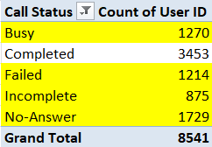

Call completed =3453

Other status(Busy, failed, incomplete, no answer) =5088

Percent of completed calls = (Completed calls * 100) / Total calls

= (3453*100)/8541

= 40.43 %

Percent of incomplete calls (other status) = 59.57%.

# REASON 3-

The 78.72% of the total net income for the company comes from Call service only.

And the 78.46% of the total income for the astrologer comes from Call service.

So if the call service is a key revenue driver, investing in training programs would be a strategic move to sustain and enhance that success.

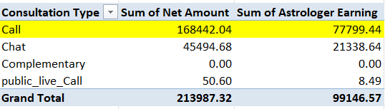

Percent of call income = (Call income * 100)/Total income

**2) What are the potential risks of each investment option (hiring, training,**

**technology upgrades), and how can they be mitigated?**

**Name the chart/spreadsheet function you will use for solving the problem?**

**Ans-**

**1} HIRING –**

## Potential risks –

1) Onboarding cost –To onboard any employee the company have to bare the onboarding cost, which can be high as company will pay certain agency to recruit perfect fit employee for them.

2) Training cost - Investing time and money into training a new hire who turns out to be a poor fit can be waste of resources.

3) Not retained for long term – If the individual is not retained long-term, then it will be waste of the time and resources.

4) Lack of Skills: Misjudging a candidate’s qualifications during the hiring process could lead to poor performance and potential rework.

5) Damage to Reputation: If a new hire behaves inappropriately or unethically ,it can damage the company’s reputation.

## Mitigating these risks involves-

1) Long 4-5 rounds of interview.

2) Clear communication about job expectations.

3) And ensuring a good cultural fit during the hiring process.

## 2} TECHNOLOGY UPGRADES-

There is need for technology upgrades because 69.62% of total users use chat service. And Gurucool is only one platform which provide the service of the Chat to the users. But the average rating of the Gurucool is 2.71, which is the clear indicator of unsatisfied users. So it is very necessary to improve technology and provide satisfaction to the users . Investing in technology upgrades will help to improve the overall experience and will help to increase the retention rate of the users. But there are some risks in upgrading technology.



## Potential risks –

1) Costs – Upgrades comes with high costs. Includes hardware ,software, software licenses, equipment, training and maintenance.

2)Training requirement- Employees require training to cope up with the new technology.

3) Performance issue- The new technology may not deliver the expected performance or may require more resourses.

4) Loss of data – During the upgrade data might get corrupted or loss.

### Mitigating these risks involves-

1) Create a detail budget for potential costs before upgrading.

2) Provide training and support to employees.

3) Backup all the data before upgrade.

## 3} TRAINING-

Only 27.49% of users are satisfied with the service. To improve that, company must invest in training program. Investing in training programs would be a strategic move to sustain and enhance that success.

**Total users = 28027**

**Satisfied user (Rating-5,6,7,8) = 27.49 %**

Formula – {(sum of users that gave rating 5,6,7,8)*100} / Total users

**Unsatisfied user (Rating-0,1,2,3,4) = 72.51 %**



## Potential risks –

1) High cost – Training programs involving external trainers and certificcations can be expensive.

2) Employees can resign- After gaining new skills, employee might seek better opportunity and can resign.

3) Ineffectiveness of training- The training may not be relevant or aligned with business goals.

## Mitigating these risks involves-

1) Focus on in-house training and assess cost benefit ratio.

2) Create positive environment and growth opportunity. Also introduce contract agreements.

**3) How does AstroSage call center performance compare to that of AstroGuru in**

**terms of average call volume, customer satisfaction, and agent performance?**

**Will you use any aggregation function or a visualization here to solve the**

**problem?**

**Ans –**

 

**The average call volume per day is 250 calls .**

There are 131 gurus who can receive calls.

But out of 8541 total calls only 3453 calls are getting completed, which is 40.43 %.

That means 59.57 % of users are not getting the service despite of booking the call session. This is the reason why the average rating of the call service is 3.5 only.

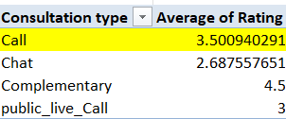

**If the rating of the Astrologers increase then company rating also increase.**

The 78.72% of the total net income for the company comes from Call service only.

And the 78.46% of the total income for the astrologer comes from Call service.

So if the call service is a key revenue driver, investing in training programs would be a strategic move to sustain and enhance that success.



Percent of call income = (Call income * 100)/Total income

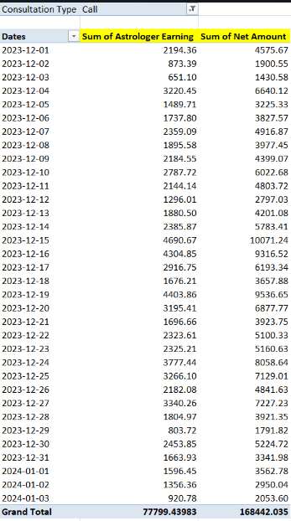

**The performance of agents are very important to the company as they are interconnected. Because there is the correlation to the agent earning and net amount.**

**Correlation of agent earning and net amount= 0.9970**

(Formula - =CORREL())

A correlation of 0.99 suggests a very strong positive linear relationship between two variables. This means that as one variable increases, the other variable almost always increases in a nearly predictable manner. The closer the correlation coefficient (r) is to 1, the stronger the relationship, with 1 representing a perfect positive correlation.

**4) How can the call center improve its handling of peak call periods to ensure**

**high customer satisfaction?**

**Mention the functionality which you will use for giving the suggestions, will it**

**be any aggregated function or a visualization?**

**Ans –** Date 2023-12-10 and 2023-12-11 receive the highest calls.



On 2023-12-10 and 2023-12-11 receive the highest calls, but only 68.27 % users get the service while other 31.73 % got the call of astrologer busy or there call got cancel as the astrologer was busy.

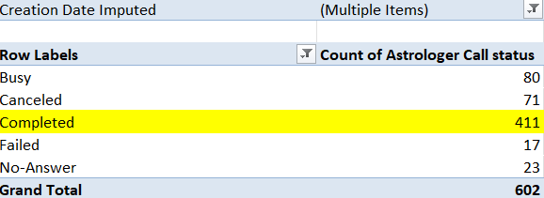

*Completed call % = (Completed calls * 100)/ total calls*

**Analyzation of peak hours -**

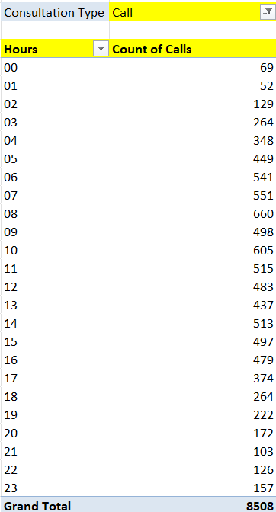 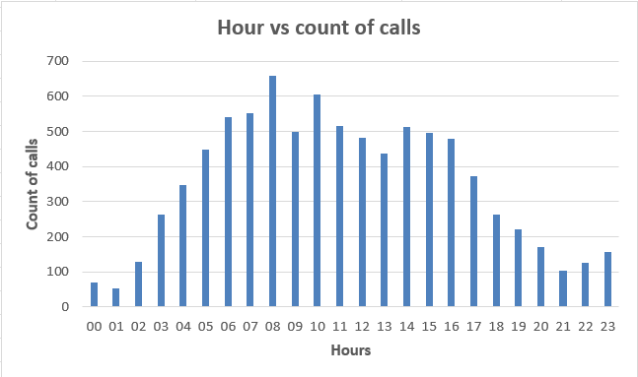

Here we can see the hourly distribution of calls. First we have to take out hours from creation time with the help of = LEFT FUNCTION , later by taking hours in row , count of calls in values and consultation type in filters and set that filter as call. This is how we can form the pivot table and later with the help of pivot table we can visualize it with chart.

## Suggestions-

1) So to come over this the company can start the option of live streaming model to engage users in live session and improve the handling of the crowd that comes in peak times. Live streaming will also bring revenue and more user to the company.

2) Shift optimization- Optimizing more agents shifts to peak periods accordingly. Ensure that more agents are scheduled during high – traffics time.

3) Use part time or freelancer agents , this reserve agents will balance the workload without increasing permanent cost.

**5) Based on historical data, what strategic initiatives should be prioritized to**

**improve overall efficiency and customer satisfaction?**

**Ans – The following strategies can help –**

**STATEGY 1- Training programs**

Only 27.49% of users are satisfied with the service.

**Total users = 28027**

**Satisfied user (Rating-5,6,7,8) = 27.49 %**

(formula- =(SUM(satisfied users)*100/total users))

**Unsatisfied user (Rating-0,1,2,3,4) = 72.51 %**



## TRAINING PROGRAM-

1) Call Handling Techniques: Train the astrologer on more efficient call-handling techniques to reduce the duration of calls without compromising the quality of service.

2) Enhancing Skills: Training can improve the skills of employees involved in the call service, leading to better customer interactions.

3) Cross-Selling: Training programs can teach employees techniques to upsell or cross-sell other services or products during calls, maximizing revenue from each interaction.

4) Adaptation to Growth: As the service grows, the company might need to scale up operations. Training helps employees adapt to new processes, tools, or technologies that support growth.

## STRATEGY 2 – Upgrade Technology.



There is need for technology upgrades because 69.62% of total users use chat service. And Gurucool is only one platform which provide the service of the Chat to the users. But the average rating of the Gurucool is 2.71, which is the clear indicator of unsatisfied users. So it is very necessary to improve technology and provide satisfaction to the users . Investing in technology upgrades will help to improve the overall experience and will help to increase the retention rate of the users. But there are some risks in upgrading technology. Upgrading technology will help the smooth experience of providing service as well as user receiving service.

**STRATEGY 3 – Hiring of Mental health professionals.**

On 2023-12-10 and 2023-12-11 receive the highest calls, but only 68.27 % users get the service while other 31.73 % got the call of astrologer busy or there call got cancel as the astrologer was busy.



**Completed call % = (Completed calls * 100)/ total calls**

**So there is need of hiring more agents. But as the time is changing. We can use different strategy to standout in market and grow our revenue.**

In today time relationship and career uncertainty is at peak. And as in India therapy is very expensive and take it as a taboo. So Astrosage can work as pseudo therapy app for them, which provide sense of certainty.

**This move can make the company stand separate among the rivals. And bring customers and revenue to the company .**

**6) What can be the key factors contributing to high customer satisfaction scores,**

**and how can these be leveraged to improve overall performance?**

**What is the basis for the suggestions? And mention how did you decide if the**

**satisfaction score affect the ratings?**

**Ans- 69.62 % of total users use chat service.**

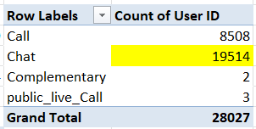

% of user using chat = (Chat user*100)/ Total user

Rating of 6,7,8 is consider as the high satisfaction range.

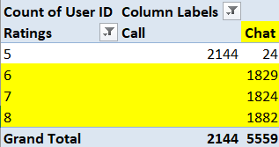

**Only chat service receive the rating of 6,7,8.**

**As 69.62% of total user use chat service and 100% of high satisfaction score is given by chat user only, then Chat service can be consider as the key factor contributing to high satisfaction score.**

## IMPROVEMENT-

Company can improve the users experience by adding features like AI chat bots and training there employees to adapt to new processes, tools, or technologies that support growth. This will help the company to improve overall performance.

**7) How should the call center balance the workload among agents to ensure**

**optimal performance and avoid burnout?**

**Mention your approach and spreadsheet function for the answer?**

**Ans –** Total call receive = 8508



**Average number of calls per day = 250** (Formula - =AVERAGE())



**% of calls gets complete = 56.41 %** {Formula= (Completed calls * 100)/ total calls}

**Call centre receive approx. 250 calls per day but only 56.41% of calls gets complete in total from astrologer side.**

## Suggestions-

1) To balance workload company can analyse the historical data. The hourly distribution of calls can help the company to balance workload accordingly among agents.



2)So to come over this the company can start the option of live streaming model to engage users in live session and improve the handling of the crowd that comes in peak times. Live streaming will also bring revenue and more user to the company.

3) Shift optimization- Optimizing more agents shifts to peak periods accordingly. Ensure that more agents are scheduled during high – traffics time.

4) Use part time or freelancer agents , this reserve agents will balance the workload without increasing permanent cost.

5) Introduce AI chart bot feature for customer care.

**8) What new technologies or tools could be implemented to enhance call center**

**operations and customer service?**

**Ans** – 1) AI chat bots for customer service.

2) Live streaming by astrologers.

3) As company use Exotel as call IVR type , which auto greet every time user call before connect with astrologer. They can add feature of playing soothing music or sholkas of Bhagavad Geeta If astrologer is busy, and they also should add feature to choose what they want to listen.

4)Feature of E-puja through video call.

5) E-commerce- Here company can sell the Gem stones and other things related to puja.

**This can improve the customer service and provide new experience to users.**

**To will help to retain the users and increase the revenue of company.**

**9)** **What metrics should be included in the final dashboard to provide a**

**comprehensive view of call centre performance and guide investment**

**decisions?**

**Ans - Dashboard**

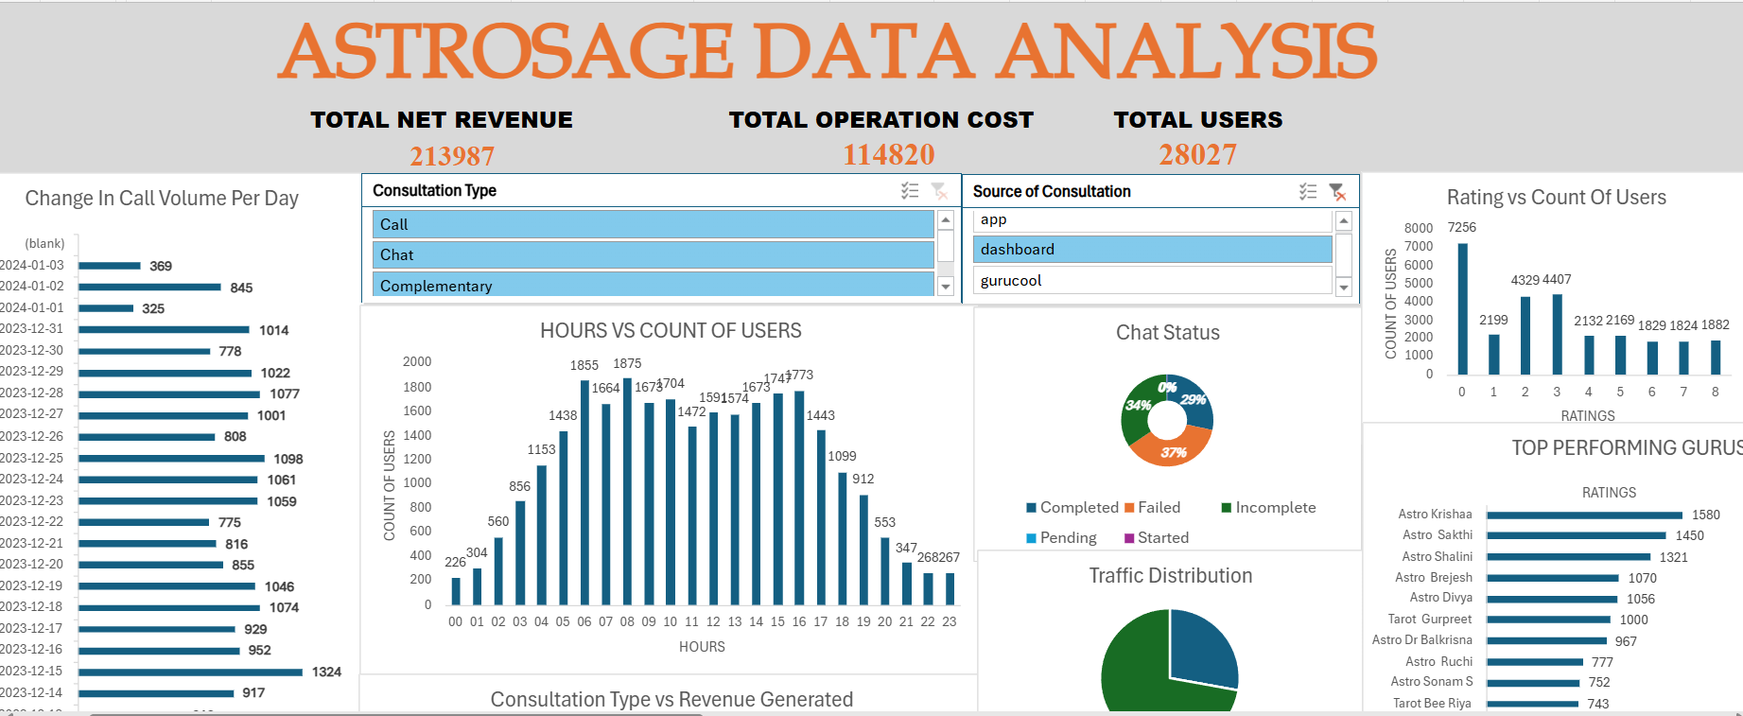

*Metrics that are included in Dashboard-*

**1) KPI (Key performance indicator) –** 1. Total net revenue.

2. Operation cost.

3. Total user.

**2) Changes in call volume day by day-** The chart will shows changes in average call volume day by day in seconds.

**3) Hour vs Count of calls (Hourly active user)–** It will show the numbers of call during different hour in day.

**4) Date vs count of user (Daily active user)–** This will show the numbers of user at that specific date.

**5) Earning vs consultancy type** – It will show the earning behind every consultancy type.

**6) Rating vs count of user (User distribution by rating)-** This will show the number of users that give specific rating.

**7) Website distribution-** Will show the distribution of users on different website or source of consultancy.

**8) Top 10 rated gurus.**

**9) Guru distribution by rating.**

**10) Call status and Chat status.**

**Slicer (Filter)- 1. Source of consultancy.**

**2. Consultancy type.**

**10) How would you allocate a 1 crore rupee investment to optimize operational**

**efficiency, enhance customer satisfaction, and boost profitability, and what**

**analysis-based recommendations would you offer to support this?**

**[you have to give bullet pointers in order to answer this question]**

**Ans – If 1 crore rupee is allocated, then I will use that money in there phases. The following phases are-**

**PHASE 1 – 30 Lakhs for Technology Upgrades.**

1) Create a detail budget for potential costs before upgrading.

2) Buy new high-tech equipment , software license, hardware and keep some money for their maintenance.

3) Invest in providing features for satisfaction of users like AI chatbots for customer care, E-puja feature through video call, etc.

4) As Exotel is the only cloud phone system with which company work, fund should be invested in building another cloud phone system to manage the burden on single phone cloud system during peak hour.

**PHASE 2 – 20 Lakhs for Training Programs.**

The training program must focus on-

**1) Call Handling Techniques**: Train the astrologer on more efficient call-handling techniques to reduce the duration of calls without compromising the quality of service.

**2) Enhancing Skills:** Training can improve the skills of employees involved in the call service, leading to better customer interactions.

**3) Cross-Selling:** Training programs can teach employees techniques to upsell or cross-sell other services or products during calls, maximizing revenue from each interaction.

**4) Adaptation to Growth:** As the service grows, the company might need to scale up operations. Training helps employees adapt to new processes, tools, or technologies that support growth.

5) Training about new technologies.

**PHASE 3 – 50 lakhs for introduction E-commerce business and Mental health category.**

**1) Mental Health category-** In today time relationship and career uncertainty is at peak. And as in India therapy is very expensive and take it as a taboo. So Astrosage can work as pseudo therapy app for them, which provide sense of certainty.

**This move can make the company stand separate among the rivals. And bring customers and revenue to the company .**

**2) E-commerce -** Here company can sell the Gem stones and other things related to puja. This will help the company to generate extra revenue and also to attract new customers.

This is how I will invest 1 cr. To enhance customer satisfaction and boost profitability.